Worksheet
TRUE/FALSE AND SHORT ANSWER
- Culture and institutions are fundamental factors to understand the divergence between rich and poor countries.
-True, culture is the norms and beliefs of people and institutions includes schools, Therefore, one needs to know the ways and educational level of the people to understand the divergence between rich and poor countries
b) Consider the Solow model with a Cobb-Douglas production function: , where A=1 and H=100. Assume a constant investment rate of 40% of GDP and a depreciation rate of d=10%. The steady state level of capital is 80 and investment is 32.
-TRUE, investment increases growth of GDP and National come .

b)In the recent financial crisis 2007-09, the US unemployment rate rised to 10%. This evolution of unemployment may be a consequence of a contraction of the supply of labor in an economy with downward wage rigidity.
True, downward nominal wage rigidity and contraction of labor supply contributed towards 2007-2009 financial crisis .
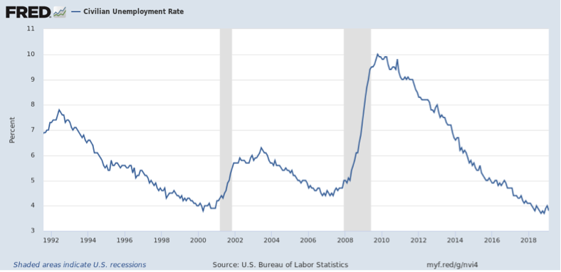

C)The recent evolution of US real interest rates may be partially explained by income inequality.
- True, since real interest rates has a distorting impact on need fulfillment, full employment, optimal growth, equitable distribution of income and wealth and economic stability.
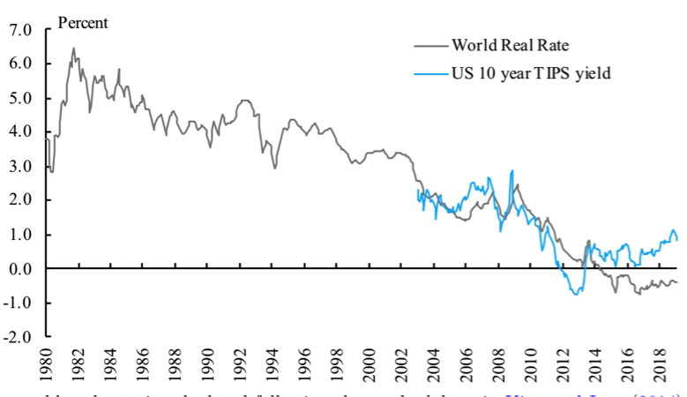

D)Consider the balance sheet below. Assume that due to an economic downturn, the value of long-term investments declines by 10%. Then, the value of stockholders' equity becomes $115 Billion.

Securitas Bank Balance Sheet
Assets |  | Liabilities
Reserves and Cash Equivalents | $ 50 Billion | Demand Deposits | $200 Billion
Long-term investments | $315 Billion | Borrowing from Other Banks | $ 50 Billion
Total Assets | $365 Billion | Stockholders’ Equity
 |  |  | $115 Billion

E)If households in the UK become pessimistic about the future as a consequence of the Brexit negotiation process, we should expect the real interest rate to increase in the UK.
False, interest rate will decrease and to be negative, because if the deal is reached on Brexit negotiation UK’s trade on global market will be immensely affected.
F)Banks transform short-term liabilities into long-term investments.
- True, banks convert short-term liabilities into investments by providing loans; thereby transforming maturities

G)In the solow model, increases in the saving rate, s, are a source of sustained growth in real GDP.
-True, an increase in saving raises the capital stock and thus raises the full-employment national income and product. The national income and product rises, and the rate of growth of national income and GDP increases.
H)A bank run is a situation where a large proportion of a bank’s depositors try to withdraw their money at the same time.
True, a bank occurs when majority of the depositors withdraw money at the same time due to some reasons such as the banks’ solvency concerns.
I)An increment in household loans delinquency rates may reduce stockholders' equity in financial institutions.
True, increase in loans delinquency rate may reduce stockholders’ equity due to loan defaults.

Multiple choice: Highlight the correct answer
1.Assuming all else equal, what will happen to the supply of labor if the labor force participation increases?
It will cause an upward movement along the supply curve of labor.
It may cause a rightward shift in the supply curve of labor.
It will cause a downward movement along the supply curve of labor.
It will cause a leftward shift in the supply curve of labor.

2.The covid shock:
Decreased the population that is not in the labor force in the US
Decreased permanent unemployment in the US.
Increased temporary unemployment in the US.
Increased the labor force participation rate in the US

3.If the number of employed workers in an economy is 7 million, the number of unemployed people in the economy is 2 million, and the number of adults not in the labor force is 1 million, the labor force participation rate in the economy is:
66.66%.
62%
85.71%.
90%

4.QUESTION 8
- What will happen to the demand curve for workers in steel mills if the price of an input decreases assuming all else equal?
. | . | - It will cause a downward movement along the demand curve of the workers.
. | . | - It may cause a rightward shift in the demand curve of the workers.
. | . | - It will cause a leftward shift in the demand curve of the workers.
. | . | - It will cause an upward movement along the demand curve of the workers.

5.QUESTION 10
5.Assuming all else equal, if companies decide to distribute less dividends, it is likely to cause:
. | . | - An upward movement along the current credit supply curve of the household.
. | . | - The current credit supply curve to shift to the right.
. | . | - The current credit supply curve to shift to the left.
. | . | - A downward movement along the current credit supply curve of the household.

6.The number of adults not in the labor force of a country equals 5 million and the number of individuals employed is 13.5 million. If there are 20 million potential adult workers in the economy, what is the current unemployment rate in this country?
12.45%
38%
10%
21%

7.Which of the following statements is true for the US?
U3 and U6 measures of unemployment are below pre-covid levels.
The labor market is running relatively slack.
We should expect LFPR to decrease in the coming months.
The covid shock does not have an effect on inequality

8.Which of the following statements is true?
Culture and the geography of a nation can be considered proximate causes of prosperity.
Cultural and geographical conditions of a nation can be considered proximate causes of prosperity.
Culture and the geography of a nation can be considered fundamental causes of prosperity.
Stock of human capital and physical capital available to a nation can be considered fundamental causes of prosperity.

9.What will happen to the demand curve for skilled workers if some technology that increases their productivity (e.g. AI) is introduced assuming all else equal?
It will cause an upward movement along the demand curve of skilled workers.
It will cause a leftward shift in the demand curve of skilled workers.
It will cause a downward movement along the demand curve of skilled workers.
It may cause a rightward shift in the demand curve of skilled workers.

10.According to the Solow model, given the levels of total efficiency units of labor (H) and technology (A):

Investment (I) is an increasing fraction of output (Y)
Efficiency units of labor do not play any role in the determination of the steady-state level of GDP.
Output grows faster when it is relatively closer to the steady-state level.
The model is not able to explain sustained growth.

11.All else equal, a decrease in government deficit is likely to cause a(n):
Upward movement along the credit demand curve.
Rightward shift of the credit demand curve.
Downward movement along the credit demand curve.
Leftward shift of the credit demand curve.

12.QUESTION 20
- Assuming all else equal, if companies decide to invest less, it is likely to cause:
. | . | - The current credit demand curve to shift to the left.
. | . | - The current credit demand curve to shift to the right.
. | . | - An upward movement along the current credit supply curve of the household.
. | . | - A downward movement along the current credit supply curve of the household.

13.Assuming all else equal, if a household is pessimistic about future income, it is likely to cause:
The current credit supply curve to shift to the right.
An upward movement along the current credit supply curve of the household.
A downward movement along the current credit supply curve of the household.
The current credit supply curve to shift to the left.

14.QUESTION 23
- Which of the following statements is true?
. | . | - A full time college student is not a potential worker.
. | . | - A stay at home father is not a potential worker.
. | . | - An unionized electrician is not part of the labor force.
. | . | - A former lawyer seeking new employment is part of the labor force.

15.QUESTION 24
- Unemployment arising from job search is called:
. | . | - Disguised unemployment.
. | . | - Frictional unemployment.
. | . | - Structural unemployment.
. | . | - Cyclical unemployment.

- 16.QUESTION 26
- If the institutions in an economy change from being inclusive to extractive, then in the economy:
. | . | - The number of entrepreneurs will decrease.
. | . | - The returns to entrepreneurship will increase.
. | . | - The opportunity cost of entrepreneurship will decrease.
. | . | - Existing entrepreneurs will earn higher profits.

17.QUESTION 27
- Assuming all else equal, if a household is pessimistic about future income, it is likely to cause:
. | . | - The current credit demand curve to shift to the right.
. | . | - An upward movement along the current credit demand curve of the household.
. | . | - The current credit demand curve to shift to the left.
. | . | - A downward movement along the current credit demand curve of the household.

